


Database Management Lab Sheet (ENCS205)
Bachelor of Technology in
Computer Science and Engineering

Submitted by
Sahdev Sharma (2401010092)
B. Tech CSE (Core) – 4th Semester Section: A

Submitted To:
MS. Mansi Kajal

School of Engineering & Technology
K. R. MANGALAM UNIVERSITY
Sohna, Haryana 122103, India feb-2026

Experiment- 6
Create Client_master with the following fields [ClientNO, Name, Address, City, State, bal_due] .
( a ) Insert five records .
( b ) Find the names of clients whose bal_due> 5000 .
( c ) Change the bal_due of ClientNO “ C123” to Rs. 5100 . ( d ) Change the name of Client_master to Client12 .
( e ) Display the bal_due heading as “BALANCE” .

[Query] :
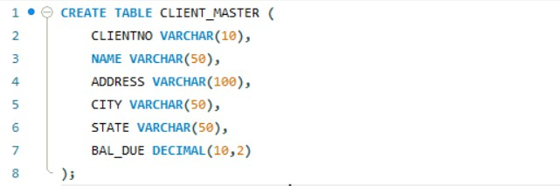

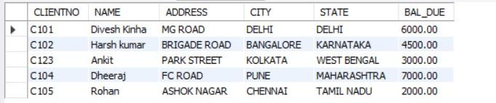
( a ) Insert five records .
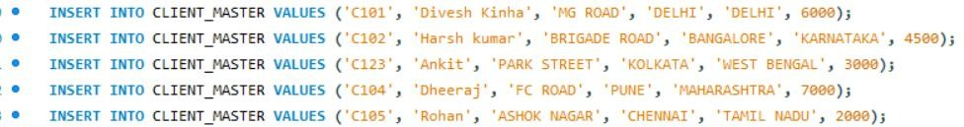

( b ) Find the names of clients whose bal_due> 5000 .
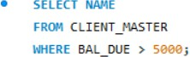
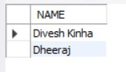

( c ) Change the bal_due of ClientNO “ C123” to Rs. 5100 .
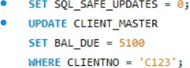
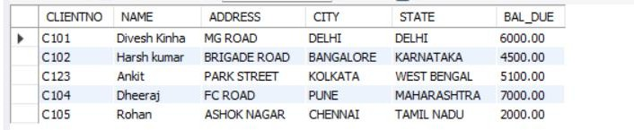

( d ) Change the name of Client_master to Client12 .


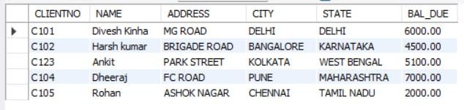

( e ) Display the bal_due heading as “BALANCE” .

